**Project Report**

**Title : Data Science Salaries Analysis Dashboard**

**Name : Almeen Zahra**

**Section : 5**

**Email : Sabirbarcha512@gmail.com**

**Tableau Link : [https://public.tableau.com/app/profile/almeen.zahra](https://public.tableau.com/app/profile/almeen.zahra" \t "_blank)**

**Github Link :** **https://github.com/Almeen685**

**1. Dataset Overview**

* I am working with a dataset that contains 3355 rows and 11 columns. Key columns include:
  + **work\_year:** The year of work.
  + **experience\_level:** The level of experience of the employee.
  + **employment\_type:** Type of employment (full-time, part-time, etc.).
  + **job\_title:** The title of the job (e.g., Data Scientist, Data Engineer).
  + **salary\_in\_usd:** The salary of the employee in USD.
  + **employee\_residence:** The location of the employee.
  + **remote\_ratio:** The percentage of work that can be done remotely.
  + **company\_location:** The location of the company.
  + **company\_size:** Size of the company (S: small, M: medium, L: large).

**2. Worksheet 1: Total Companies by Size and Location (Pie Chart)**

**Goal**: Visualize the distribution of companies by size and location using a pie chart.

This chart shows the distribution of companies by size and location. The pie chart represents the percentage of companies in each size category (Small, Medium, Large). The chart indicates that most companies are medium-sized, followed by large and small companies. This information provides insights into the company landscape in the analyzed data.

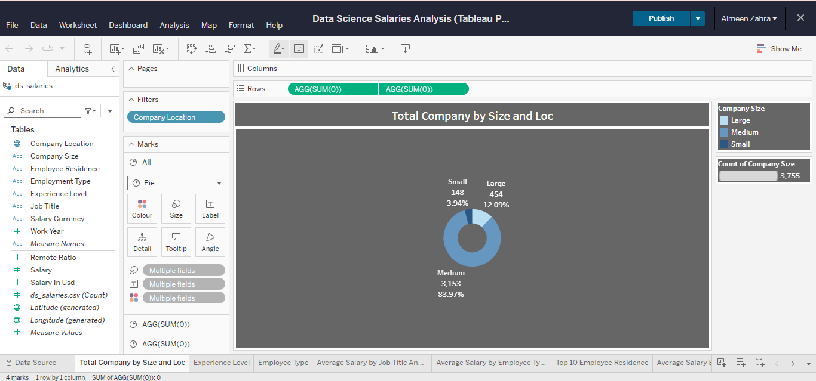

**3. Worksheet 2: Experience Level Distribution (Pie Chart)**

**Goal**: Create a similar chart as Worksheet 1 but based on experience level.

This chart shows the distribution of companies by size and location. The pie chart represents the percentage of companies in each size category (Small, Medium, Large). The chart indicates that most companies are medium-sized, followed by large and small companies. This information provides insights into the company landscape in the analyzed data.

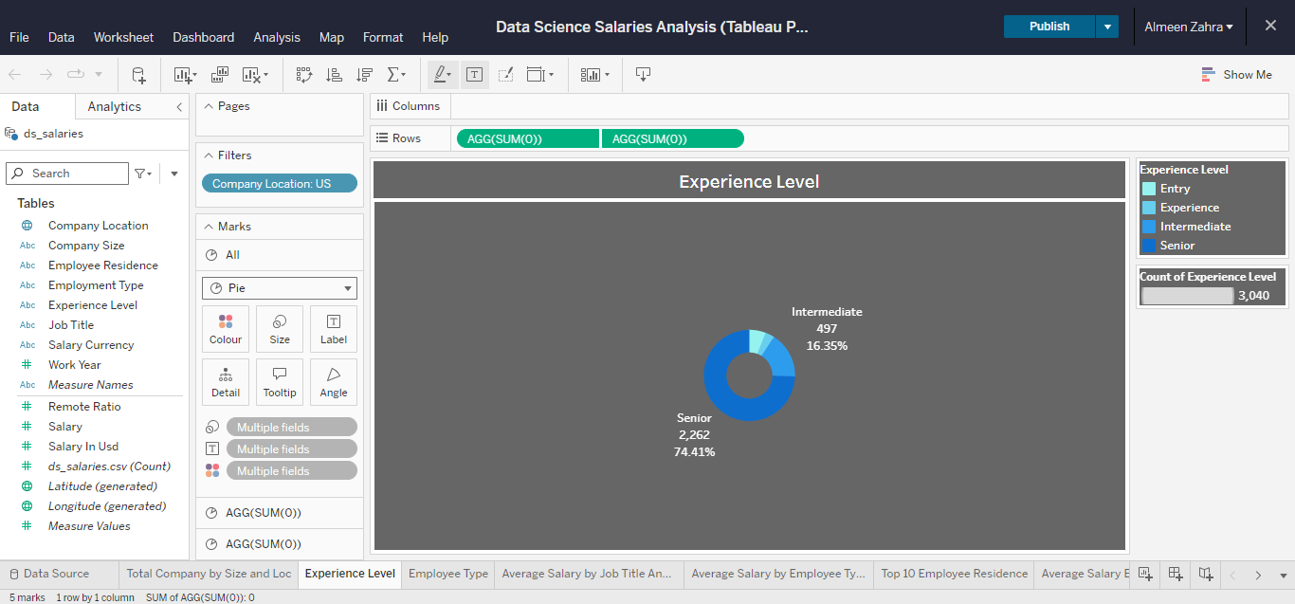

**4. Worksheet 3: Combine Company Size and Experience Level**

**Goal**: Create a chart combining company size and experience level in a pie chart.

This chart shows the distribution of data science employees by employment type. The pie chart represents the percentage of employees in each type (Contract, Freelance, Full-Time, Part-Time). The chart indicates that most employees work full-time, with a small percentage working part-time, freelance, or on contract. This information provides insights into the employment trends in the data science field.

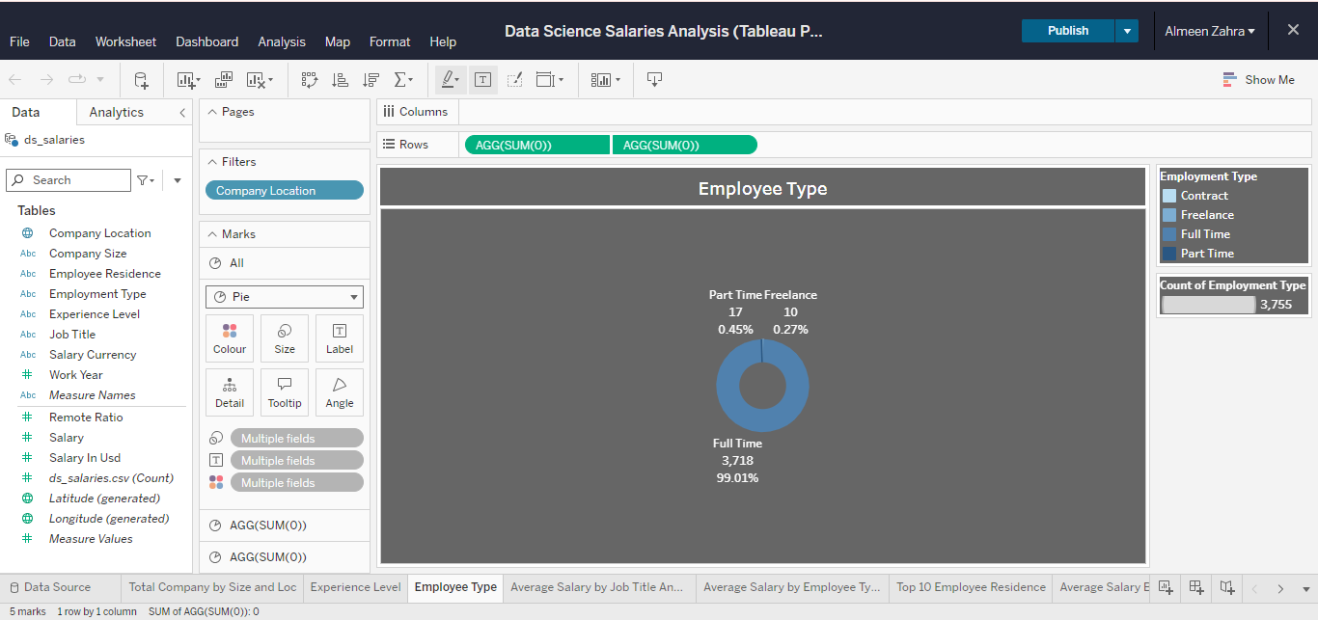

**5. Worksheet 4: Average Salary by Experience Level and Job Title (Highlight Table)**

**Goal**: Create a highlight table to show average salary by experience level and job title.

This chart shows how average data science salaries vary based on job title and experience level. The x-axis lists different job titles, and the y-axis represents average salary in USD. Each dot represents the average salary for a specific combination of job title and experience level. The chart helps visualize the relationship between these factors and salary.

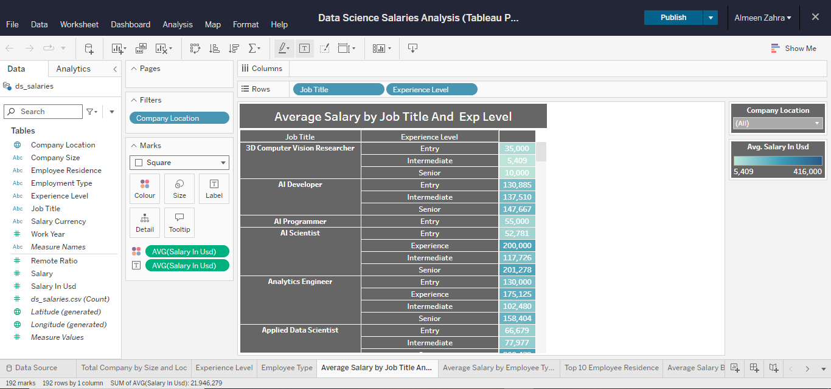

**6. Worksheet 5: Average Salary by Country (Map)**

**Goal**: Display the average salary per country using a geographical map.

This sheet shows a map of the world with different countries colored based on their average data science salaries. The darker the color, the higher the average salary. It also provides information about the data used, such as the dataset name and the columns included.

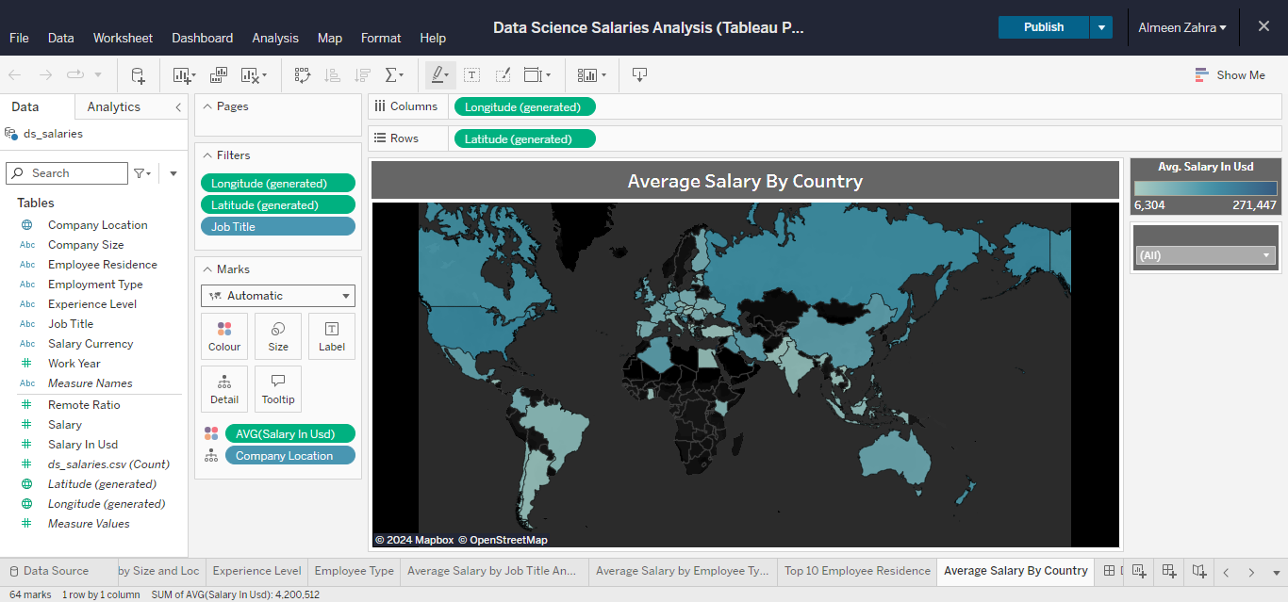

**7. Worksheet 6: Average Salary by Experience Level and Employment Type (Circle Chart)**

**Goal**: Display the average salary by experience level and employment type in a circular chart.

This chart shows how average data science salaries vary based on experience level and employment type. The x-axis represents different experience levels (Entry, Intermediate, Senior), and the y-axis represents average salary in USD. Each dot represents the average salary for a specific combination of experience level and employment type (Contract, Freelance, Full Time, Part Time). The chart helps visualize the relationship between these factors and salary.

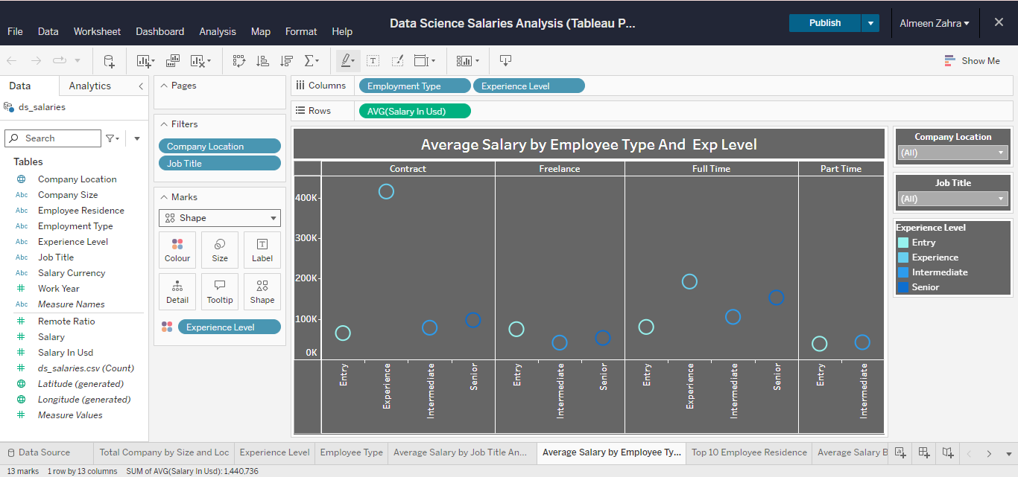

**8. Worksheet 7: Top 10 Employee Residences (Horizontal Bar Chart)**

**Goal**: Create a bar chart for the top 10 employee residences.

This chart shows the top 10 countries where data scientists reside, based on the number of employees in the dataset. The x-axis lists the countries, and the y-axis represents the count of employees. The United States has the highest number of data scientists, followed by Great Britain and Canada. This chart provides insights into the geographic distribution of data science professionals.

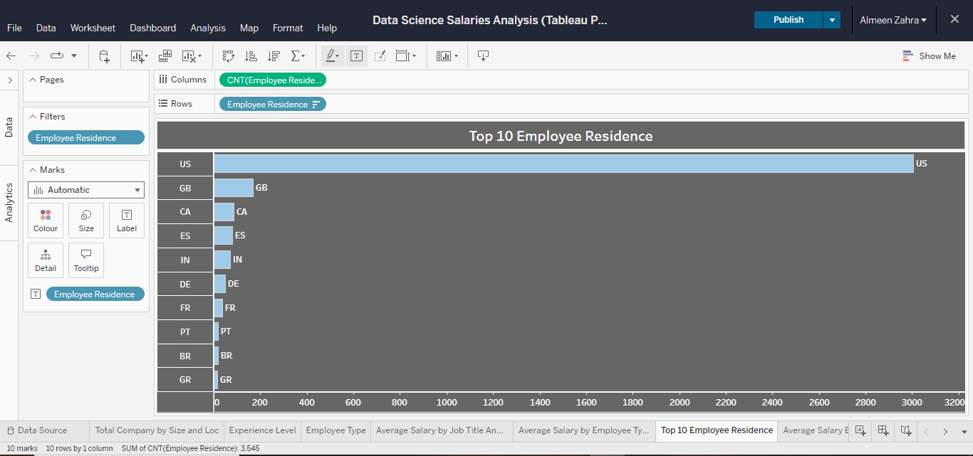

**9. Dashboard Layout**

**Goal**: Combine the charts into a comprehensive dashboard.

**Top Left:**

* **Average Salary by Exp Level and Empl Type:** This chart shows how average salaries vary based on experience level and employment type. Each dot represents the average salary for a specific combination of these factors.

**Top Right:**

* **Total Companies by Size and Loc:** This pie chart displays the distribution of companies by size (Small, Medium, Large). It provides insights into the company landscape.
* **Average Salary By Country:** This map shows the average salary for data scientists in different countries, visualized by color intensity.

**Bottom Left:**

* **Top 10 Employee Residence:** This bar chart lists the top 10 countries where data scientists reside, based on the number of employees in the dataset.

**Bottom Right:**

* **Average Salary By Job And Exp Level:** This chart shows how average salaries vary based on job title and experience level. Each dot represents the average salary for a specific combination of these factors.
* **Employee Type:** This pie chart displays the distribution of data science employees by employment type (Contract, Freelance, Full-Time, Part-Time).

Overall, the dashboard offers a holistic view of data science salaries, considering factors such as experience level, employment type, job title, company size, and location.

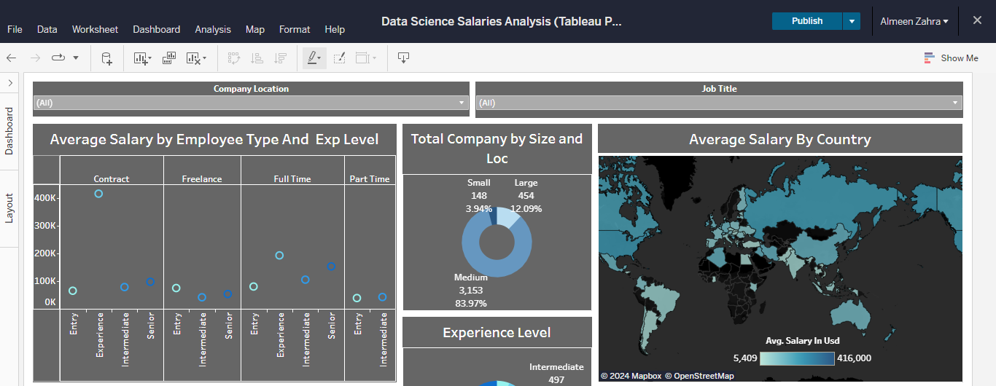

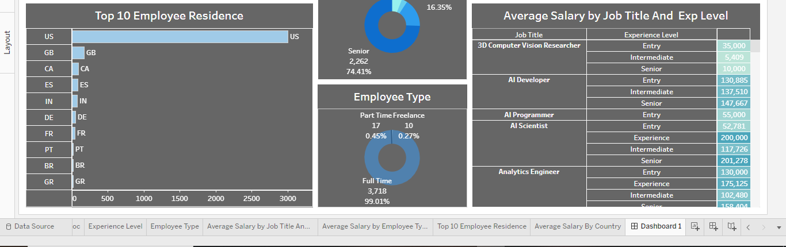

**Conclusion**

By following these steps, you will create a well-structured Tableau dashboard to analyze data science salaries across various regions, experience levels, and job titles. The interactive filters and diverse visualizations will allow users to easily explore the data and extract insights.